

**ESP-32 BASED WATER TANK PROJECT**

USER MANUAL

prepared for   
Michelin Lanka (Pvt) Ltd.

prepared by   
ENG. MILAN HARSHA KUMARA

Mr. J.C.B. Kehelwattha

Mr. P.D.N.D. SILVA

### **ESP32**

* Create Wi-Fi connection:
  + SSID : “Wokwi-GUEST”
  + Password : “*None*”
* Provide Power to the device.
* Wait till the two LEDs Turn Green

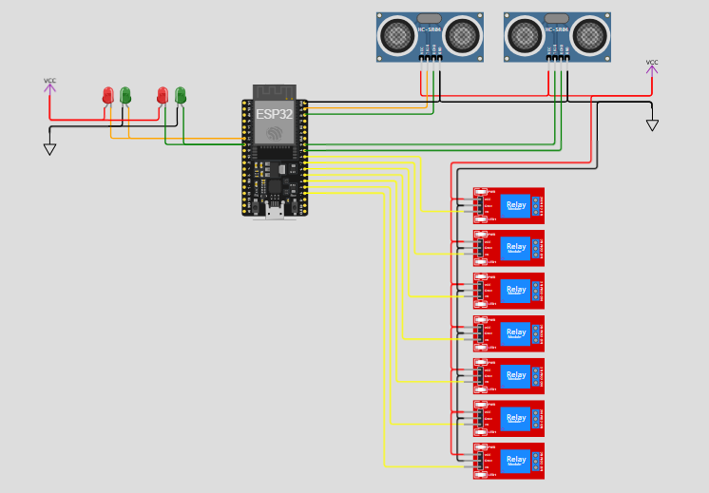

Figure 1: Proposed project circuit diagram

**MOBILE APPLICATION**

##### **Before Working with Your Mobile Application,**

* CAUTION: Your mobile phone must achieve minimum requirements for working with mobile applications.
  + Minimum OS: android KitKat or higher
  + Ram: 1GB.
  + Facilities: Good internet connection such as 3G or higher.

##### **How to install the mobile application?**

1. Before installing the application change some settings: -
   1. Setting->Security->Device administration.
   2. Untick the **unknown sources**.
2. You can install the app from **APK** **file**.
3. Connect your phone to internet.
4. Launch the app from your phone menu list.

##### **How to work with application.**

* After installing the mobile application, you will be able to see the main screen as follows.

#### Start screen

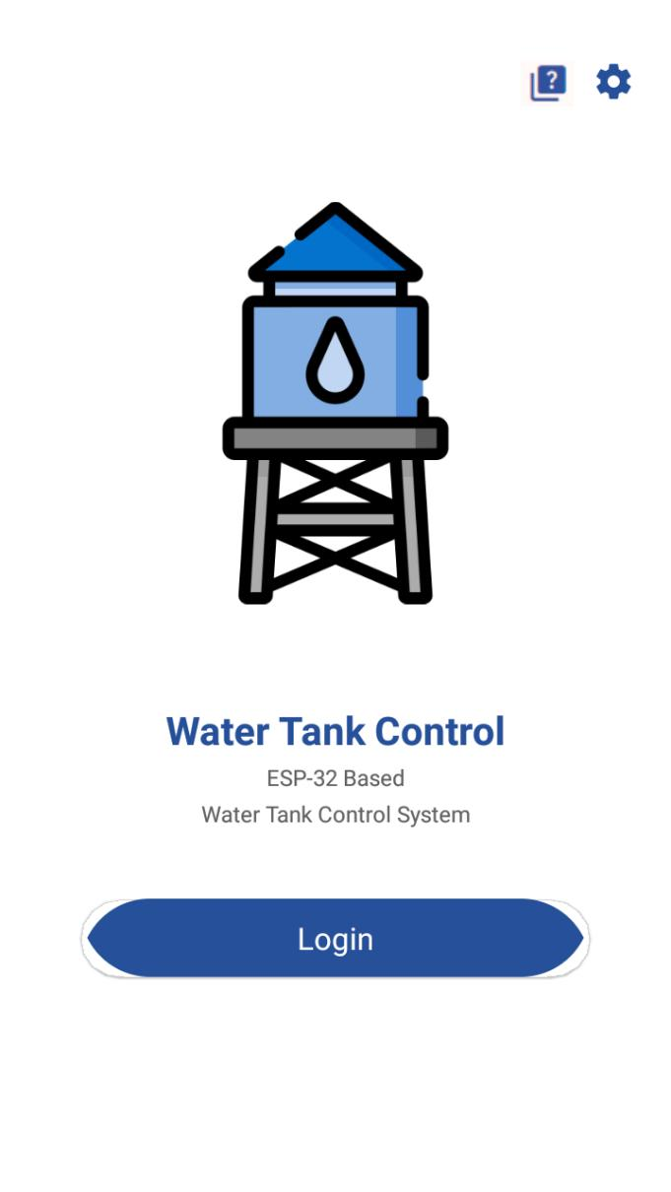

Figure 2: Main screen

1. **Login** interface provides directions to login page.
2.  **About** interface provides directions to About page.
3.  **Settings** interface provides directions to MQTT Settings page.

About screen

About page serves as a hub for copyright information. Here, users can find details on intellectual property rights, usage guidelines, and any necessary disclaimers. We aim to ensure clarity and compliance while providing a transparent and informative experience for our users.

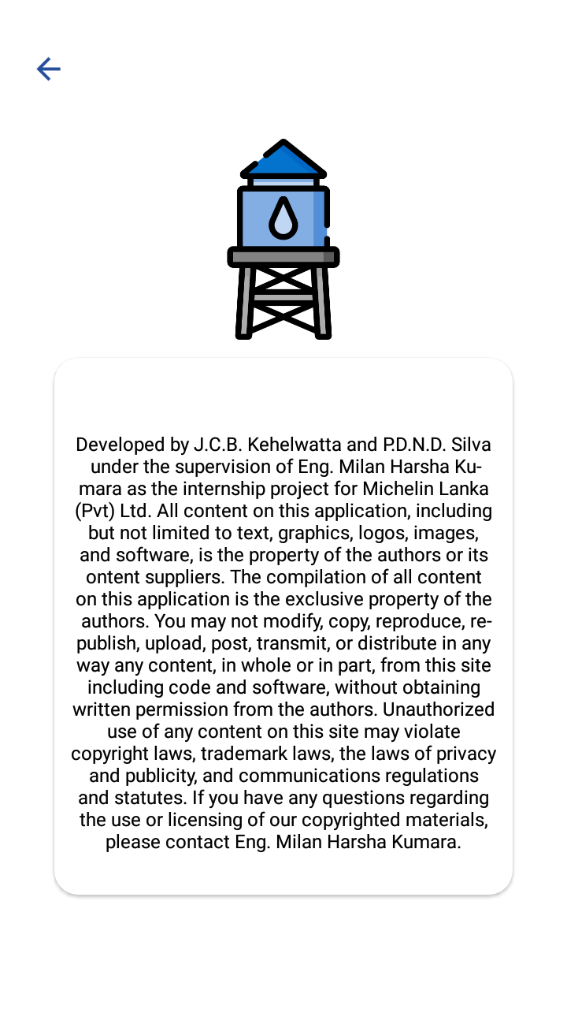

Figure 3: About screen

1. **Back:** navigate to the start screen.

Settings screen

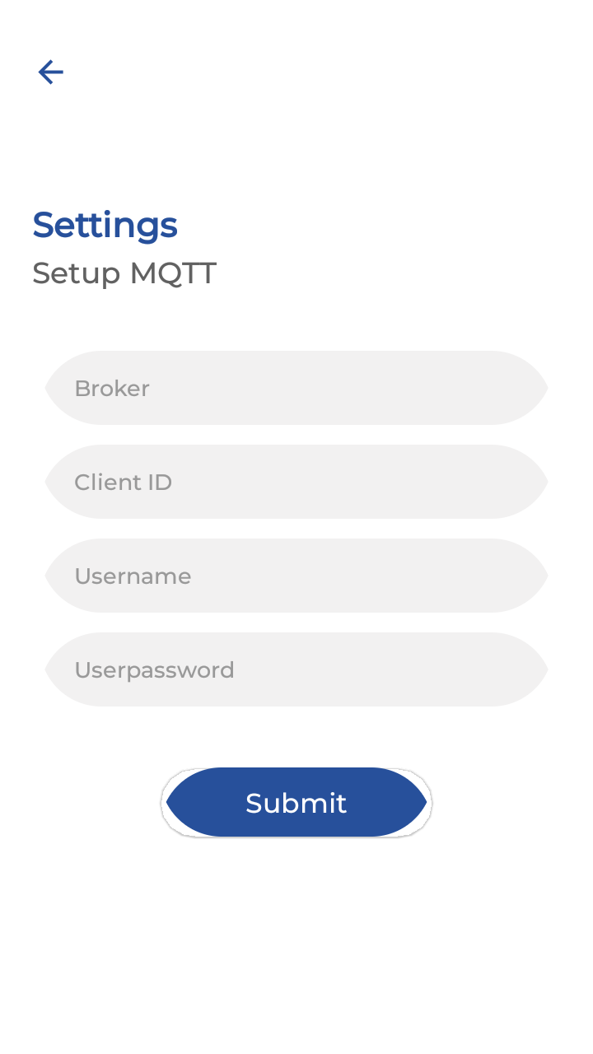

Figure 4: Settings screen

1. **Back:** navigate to the start screen.
2. **Broker:** Insert host address for MQTT broker connection.
3. **Client ID:** Insert theMQTT Client ID for MQTT broker connection.
4. **Username:** Insert the username forMQTT client authentication.
5. **Userpassword:** Insert the password forMQTT client authentication.

**Default Settings:**

**Broker** : *mqtt-dashboard.com*

**Client ID** **:** *clientId-YDpZVhf6fm*

**Username** **:** <*None>*

**Userpassword** **:** <*None>*

Login screen

The login page is the gateway to our app's ecosystem, where users can securely access their accounts and unlock personalized experiences. Designed with simplicity and security in mind, it prompts users to input credentials (email address and password).

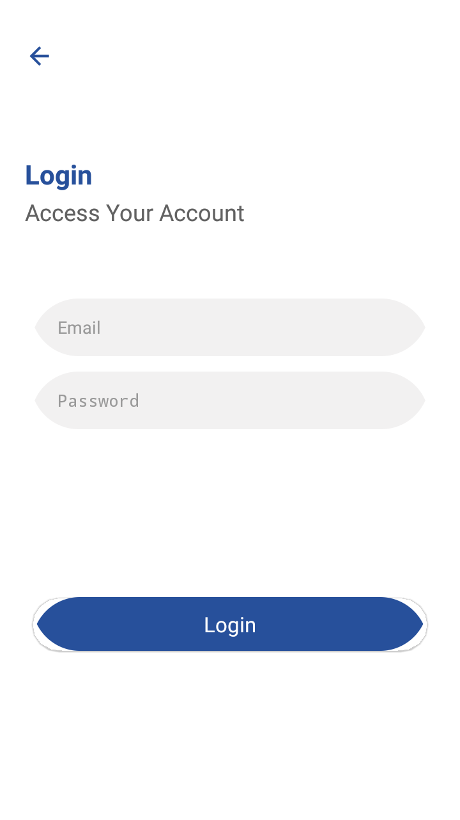

Figure 5: Login screen

1. **Back:** navigate to the start screen.
2. **Email:** Insert the email address to login to the system.
3. **Password:** Insert the password to login to the system.

**Default Settings:**

**Email** : *seuintern2024@outlook.com*

**Password** : *Test123*

Main screen

The main screen of our app serves as the command center, offering users real-time insights and control over their water management infrastructure. Through intuitive controls and indicators, users can monitor and adjust settings to optimize water usage, ensuring efficient operation and conservation.

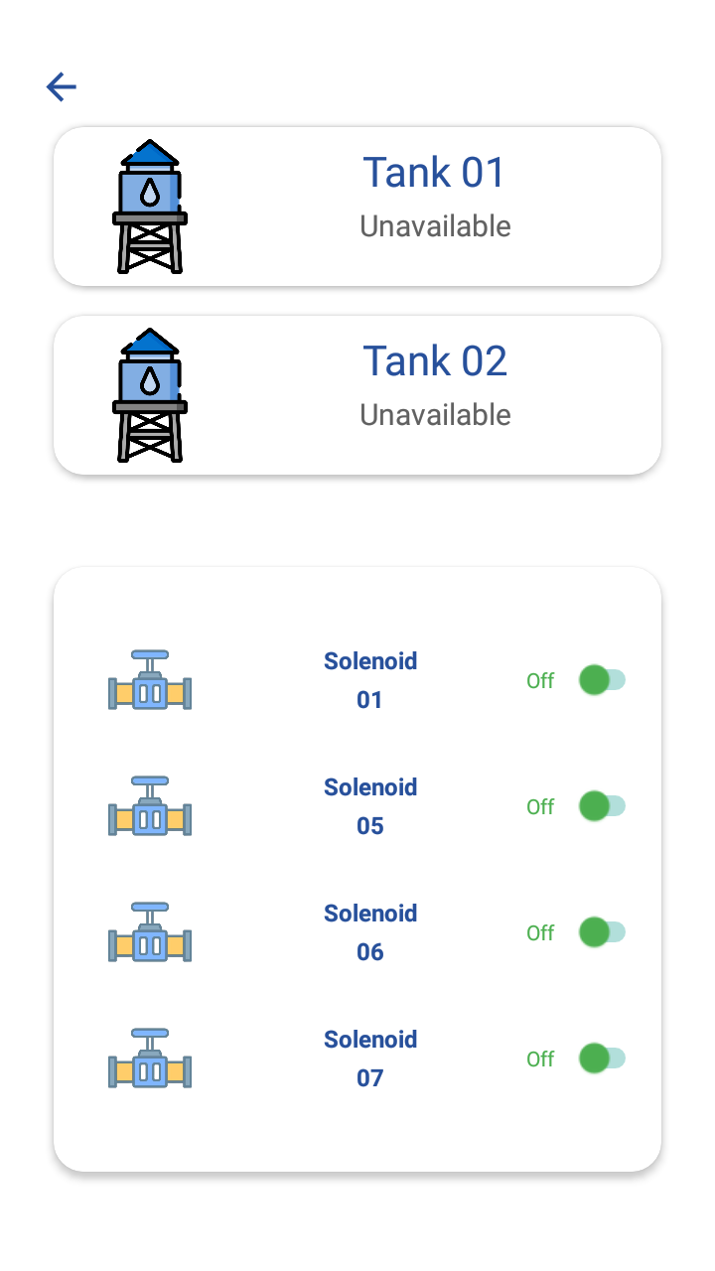

Figure 6: Main screen

1. **Back:** navigate to the start screen.
2. **Tank 1:** Indicate the water level in Tank 1
3. **Tank 2:** Indicate the water level in Tank 2
4. **Solenoid Control Panel:** Provide option to change driver solenoid status.

### **WEBSOCKETS CLIENT**



**How to use the web server?**

1. Put the server URL on the web browser.

**Server URL**: <https://www.hivemq.com/demos/websocket-client/>

#### Connection

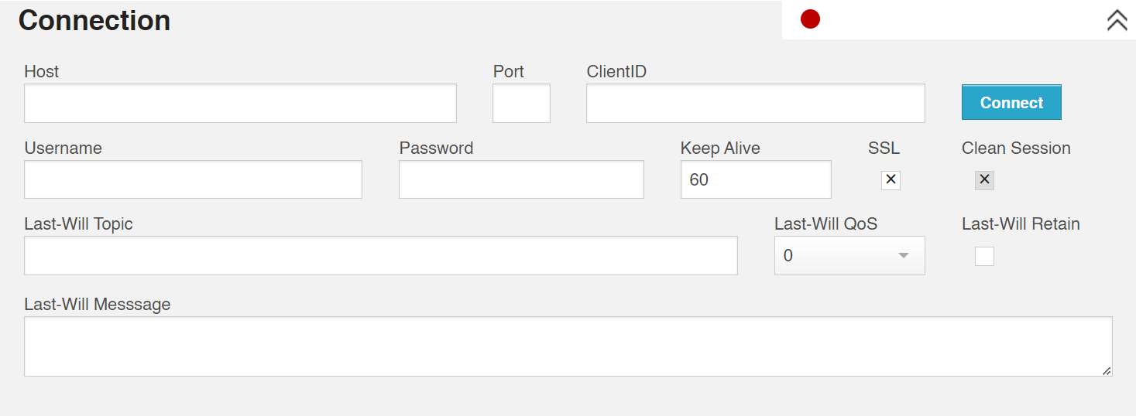

Figure 7: Connection panel

1. **Host:** Insert host address for MQTT broker connection.
2. **Port:** Insert the port for MQTT broker connection.

*HiveMQ uses port 1883 (for standard MQTT) and 8883 (for MQTT + TLS) by default.*

1. **ClientID:** Insert the MQTT Client ID for MQTT broker connection.
2. **Username:** Insert the username for MQTT client authentication.
3. **Password:** Insert the password for MQTT client authentication.
4. **Keep Alive:** Insert the number of seconds that the broker permits between when a client finishes sending one MQTT packet and starts to send the next.
5. **SSL:** Enable/Disable SSL Server.
6. **Clean Session:** Request a non-persistent session.
7. **Last-Will Topic:** Insert the topic that should automatically be published by the broker on their behalf, if or when an unexpected disconnection occurs.
8. **Last-Will QoS:** Set Quality of Service for Last-Will.
9. **Last-Will Retain:** Enable/Disable the storage of last-will message retained.
10. **Last-Will Message:** Insert the message that should automatically be published by the broker on their behalf, if or when an unexpected disconnection occurs.

**Water Tank Project MQTT Connection Settings:**

**Host:** *mqtt-dashboard.com*

**Port:**  *8884*

**ClientID:** *clientId-dvG4snHTZr*

**Username:** <*None>*

**Password:** <*None>*

**Keep Alive:** *60*

**SSL:**  *Enable* SSL Server.

**Clean Session:** *Request a non-persistent session.*

**Last-Will Topic:** <*None>*

**Last-Will QoS:** *0*

**Last-Will Retain:** *Disable* the storage of last-will message retained.

**Last-Will Message:** *<None>*

Publish

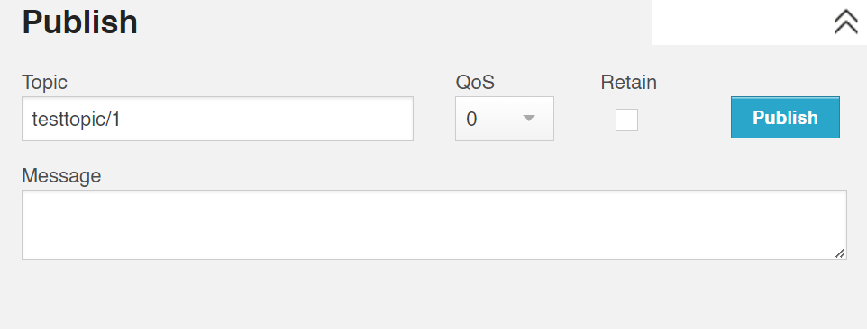

Figure 8: Publish panel

1. **Topic:** Insert the topic that should be published.
2. **QoS:** Set Quality of Service of publishing message.
3. **Retain:** Enable/Disable the storage of message retained.
4. **Message:** Insert the message that should be published.

**Water Tank Project MQTT Topics:**

**Tank-1 Water Level** : *"testtopic/101"*

**Tank-2 Water Level** **:** *"testtopic/102"*

**Solenoid-1** **:** *"Solenoid/1"*

**Solenoid-5** **:** *"Solenoid/5"*

**Solenoid-6** **:** *"Solenoid/6"*

**Solenoid-7** **:** *"Solenoid/7"*

#### Subscriptions

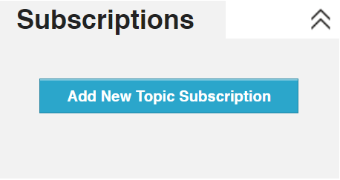

Figure 9: Subscribe panel

* Click Add New Topic Subscription.
* Set the topic and QoS that should be subscribed to in the pop-up window.
* Assign a color for the topic.
* Repeat for every topic.

**Water Tank Project MQTT Topics:**

**Tank-1 Water Level** : *"testtopic/101"*

**Tank-2 Water Level** **:** *"testtopic/102"*

**Solenoid-1** **:** *"Solenoid/1"*

**Solenoid-5** **:** *"Solenoid/5"*

**Solenoid-6** **:** *"Solenoid/6"*

**Solenoid-7** **:** *"Solenoid/7"*

#### Messages

This panel displays messages of the subscribed topics.

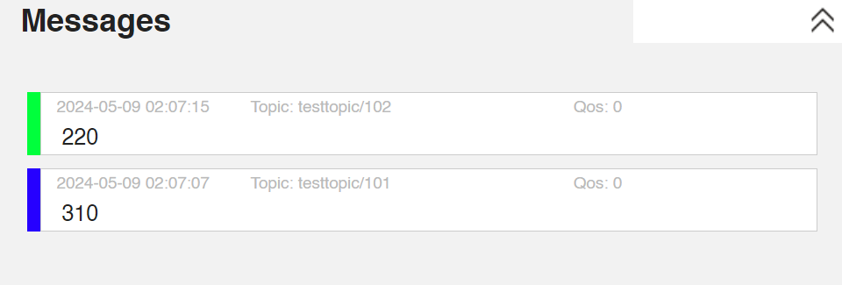

Figure 10: Message panel